Lab Practice Assignment 3

Save each test script and screenshots of test result as per question number. Make a

zip folder of all the files. Upload the zip file to Moodle.

Problem 1. (10%) Selenium

Successfully run the example in session 1. Test using Selenium

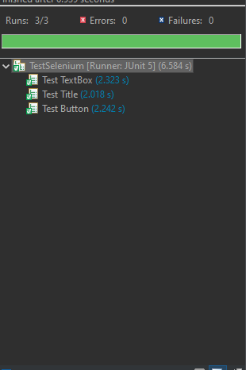

Problem 2. (10%) ID Locator

Successfully run the example in session 2.1 ID Locator.

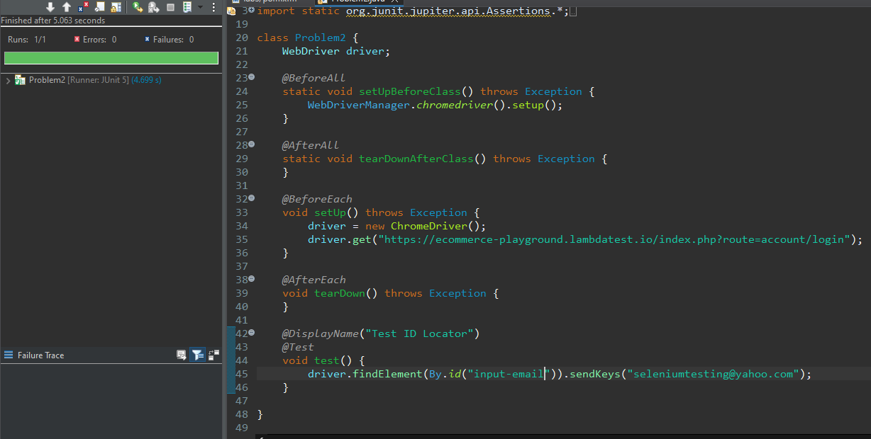

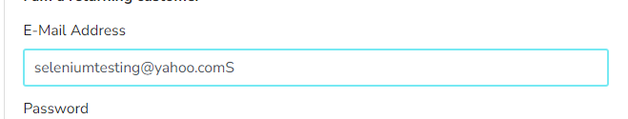

Problem 3. (10%) Name Locator

Successfully run the example in session 2.2 Name Locator

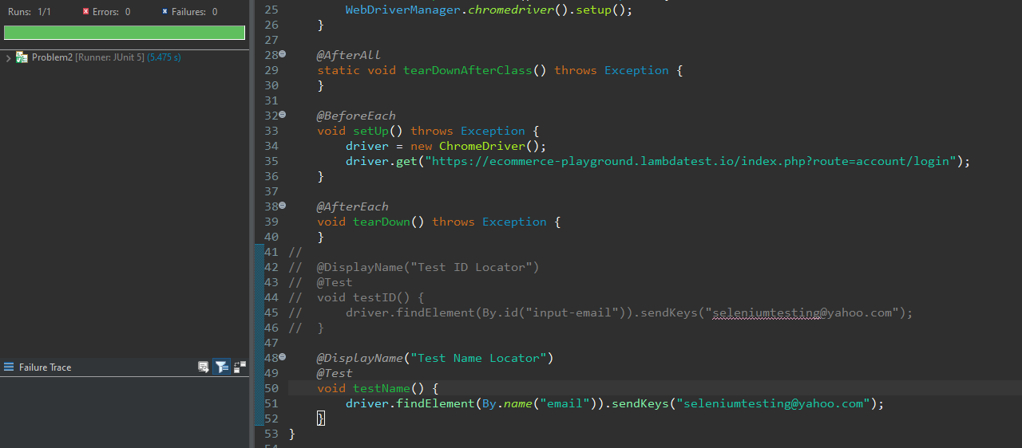

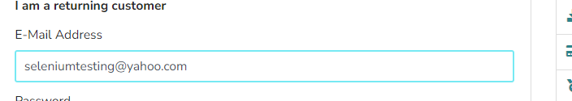

Problem 4. (10%) partialLinkText Locator

Successfully run the example in session 2.4 partialLinkText Locator

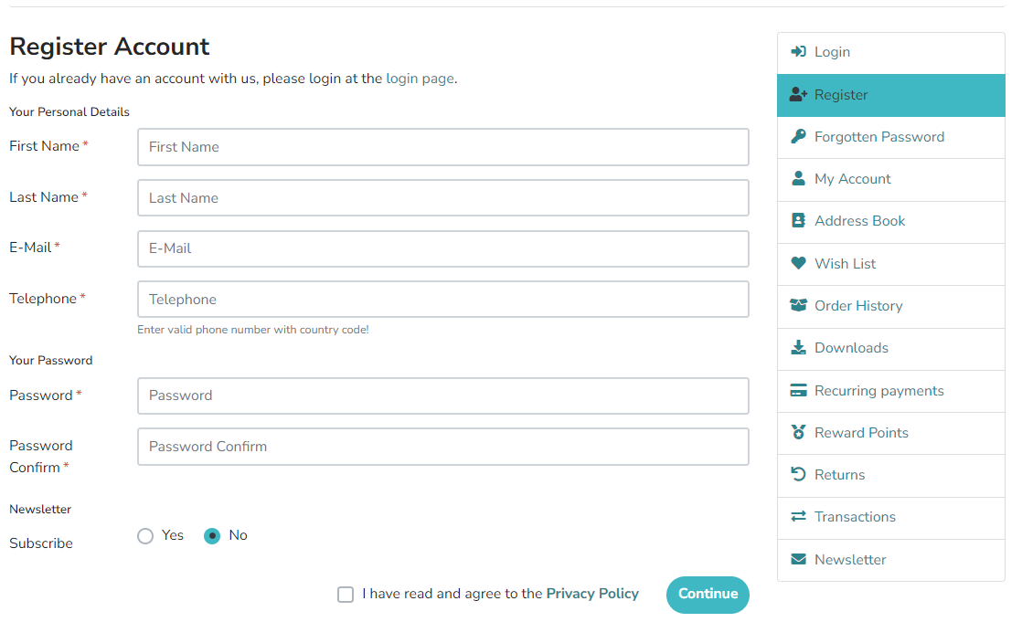

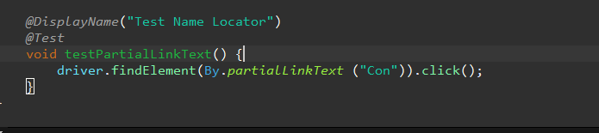

Problem 5. (10%) TagName Locator

Successfully run the example in session 2.6 TagName Locator

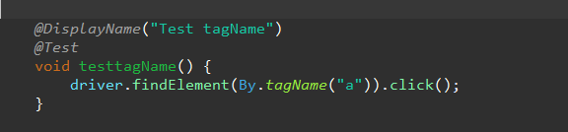

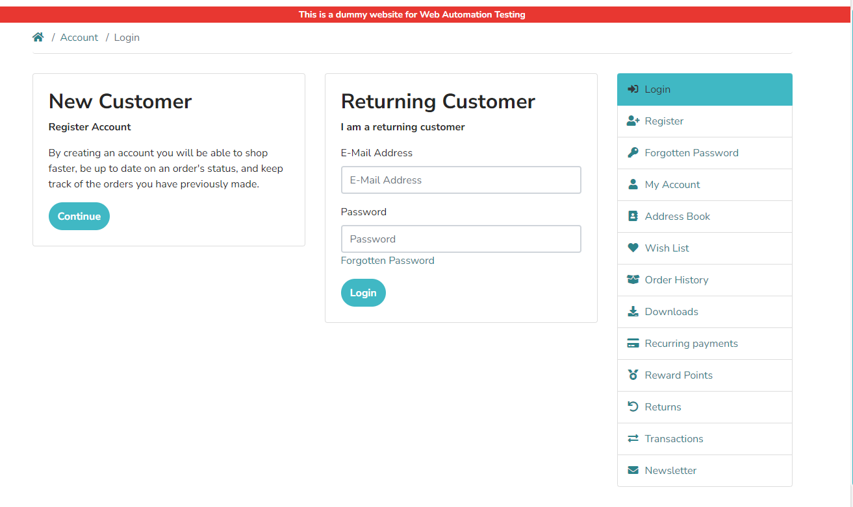

Problem 6. (10%) CSS Selectors

Successfully run any example in session 2.7 CSS Selectors

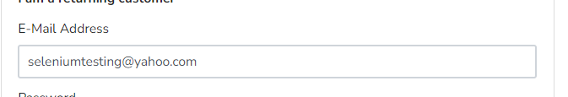

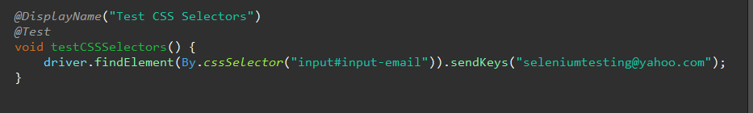

Problem 7. (10%) Relative Locators

Successfully run the example in session 2.8. Method

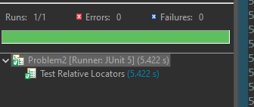

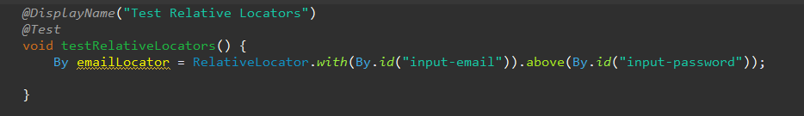

Problem 8. (10%) selectByIndex

Successfully run the example in session 3.1.2 selectByIndex

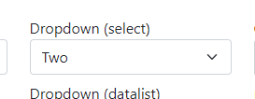

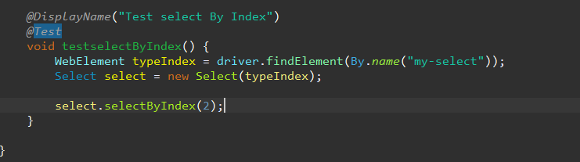

Problem 9. (10%) selectByValue

Successfully run the example in session 3.1.3 selectByValue

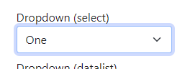

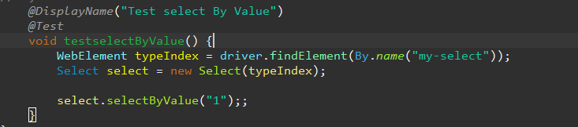

Problem 10. (10%) Submit to moodle